Deep Brain Stimulation
Unit of Functional Neurosurgery
2nd Floor 33 Queen Square


Thalamotomy and Pallidotomy
(Stereotactic lesioning)
Unit of Functional Neurosurgery
2nd Floor 33 Queen Square

If you need a large print, audio, braille, easy read, age-friendly or translated copy of this document, please contact us on xxx. We will try our best to meet your needs.
Table of Contents
1. Introduction 3
2. How can stereotactic lesioning help reduce the symptoms? 3
3. How long is the hospital stay for lesioning surgery? 3
4. What is involved in lesioning surgery? 4
5. What are the contraindications for lesioning? 4
6. What are the risks of lesioning surgery? 5
7. What will happen if I choose not to have the surgery? 6
8. What if I am not suitable for lesioning surgery? 6
9. What happens next after the multidisciplinary clinic and I am offered surgery? 6
10. What should I expect after my discharge from hospital? 7
11. What if I volunteer or get asked to participate in research? 7
12. Where can I get more information? 7
13. References 8
14. Contact details 8

Introduction
Stereotactic lesioning (Thalamotomy and Pallidotomy) is a surgical procedure which involves temporarily inserting a thin probe into a specific area in the brain which is heated to ablate a small volume of tissue in a precisely targeted brain region creating a ‘lesion’.
Stereotactic lesioning such as pallidotomy and thalamotomy is an effective treatment in dyskinesia and tremor respectively.

In thalamotomy, this involves creating a lesion in the small area called the Ventrointermedial nucleus of the thalamus (or Vim).
This procedure is performed in patients suffering with tremor. Tremor is a symptom from several different conditions affecting specific networks in the brain. Parkinson’s disease is a common condition that may cause tremor [1]. Essential tremor (ET) is another common neurological condition that causes tremor. ET has a primary symptom of rhythmic shaking of any parts of the body, with no known cause. Thalamotomy is an effective treatment in patients with essential tremor [2], [3].
Other conditions that may cause tremor are multiple sclerosis or stroke as well as a number of other rare neurological conditions.

In pallidotomy, the involved area that is being ablated is an area in the brain called the internal pallidum. Pallidotomy is effective in reducing contralateral onvoluntary excessive movement or “dyskinesia”, dystonia and the cardinal symptoms of Parkinson’s disease [1]. dyskinesia is described as writhing, repetitive and purposeless movements. The symptom is commonly seen in Parkinson’s disease. However, it can also occur in other conditions affecting the brain.

How can stereotactic lesioning help reduce the symptoms?
The lesion in the specific area blocks the pathologic signals responsible for the symptom (such as tremor or dyskinesia). The lesion reduces that abnormal brain cell activity which results to calming the symptoms (tremor and dyskinesia). These procedures are usually done only on one side of the brain contralateral to the most affected body part.

How long is the hospital stay for lesioning surgery?
Patients are admitted to the hospital 2 days prior to surgery. Patients will undergo a clinical assessment before surgery (with video recording). We may also acquire a highly detailed MRI scan (i.e. MRI connectivity) to map out the networks in the brain before surgery. The post-operative hospital stay is between 2-6 days. Patients are advised to bring their own medications when they come to the hospital.
In some cases, the tremor or dyskinesia may settle immediately after the surgery. It is important to remember that the aim of the surgery is observe the long-term benefit rather than focusing on the immediate effect.
Patients are discharged home once their condition is stable and they have not experienced severe complications after the surgery.

What is involved in lesioning surgery?
Lesioning surgery in tremor is usually performed awake. This will allow the surgeons to assess the effect of the created lesion in the brain. In some circumstances, the procedure can be performed under general anaesthetic or ‘asleep’. The neurosurgeon and the DBS team will discuss this with the patient in advance.
Patients may be advised to withhold tremor medications on the morning of the surgery. Advice will be given by the DBS nurses regarding how to take medications prior to surgery.
The surgery is not painful. Local anaesthetic will be used to numb the area. The surgical brain targets are defined on stereotactic (three dimensional) MRI studies, with a special frame attached to the head. The frame is fitted using local anaesthesia. The procedure takes 2-3 hours.

The hair will not be shaved, however, to reduce the risk of infection the hair will be washed with antiseptics. Antibiotics will be administered during surgery. Through a small skin incision, a burr hole is drilled in the frontal area and behind the hairline when possible. A thin probe (2mm in diameter) is carefully introduced into the target. The accuracy and precision of this procedure are within 1 mm error margin. The effect of lesion on the movement disorder will be assessed during surgery. After the procedure, the surgical wound is carefully closed using surgical staple clips or stitches.

What are the contraindications to lesioning?
- Pre-existing significant cognitive (thought process) decline (i.e., short term memory problems)
- Pre-existing speech and swallowing problems, will require assessment by the speech therapist
- Pre-existing significant brain structural changes according to MRI (i.e. shrunken brain)

- History of falls and balance problem

- Other medical conditions are not necessarily a contraindication but may increase further risk from the surgery such as heart problems, kidney problems, problems with breathing, prolonged bleeding problems, patients on blood thinning medication.

What are the risks of lesioning surgery?
All treatments and procedures have risks and the functional neurosurgery team will talk to you about the risks of lesioning in detail during your consultation.

Problems that may happen straight away
Complications from surgery are very rare in well-established and experienced centres. Although complications are rarely observed, these complications may result to serious disability. However, less severe complications as reversible and easy to treat and do not cause long term and serious disability.
There is a very rare risk of bleeding in the brain during the surgery. This may result in serious complications such as stroke, paralysis or death. These severe complications are rare and have never occured in our centre, nevertheless these are serious complications that patients should know. The risk of bleeding that may result to serious disability is less than 1%. The risk of seizures is also less than 1%. This can happen immediately after surgery, however, patients do not develop long-term epilepsy after surgery.
A haematoma at the surgical site can happen but this is usually of no consequences.

Other problems that may happen after surgery
Infection may occur after 1 week onwards after surgery. Infection can occur on the surgical wounds on the head. Keeping your surgical wounds clean and dry is important. This is also a rare risk (<1%).
Wound care advice:
- Before surgery, all patients are swabbed for bugs that are not sensitive to antibiotics Methicillin resistant staphylococcus aureus (MRSA). However, the common cause infection are bugs that are commonly found in the skin. All patients are advised to strictly follow a treatment regime for 5 days prior to surgery
- After surgery, patients are advised to avoid touching the wound area
- Regular hand washing is important
- Always keep the wound area clean and dry
- The wound dressing will be checked daily and will be replaced every 3 days
- Patients are advised not to wash the hair until the stitches are taken out
- Stitches are taken out 7-10 days after the surgery

Problems that may happen later
The side effects are usually a direct result of the lesioning:

- Balance problem can immediately occur after the surgery. This may be caused by the temporary swelling in the area
- Speech problem such as slurred speech
- Sensory symptoms (buzzing, tingling sensation, numbness or change in taste)
Patients are advised to report side effects during the consultation. If you have any concerns, please contact our DBS nurses (contact details provided at the end of this booklet).

What will happen if I choose not to have the surgery?
If you decide not to have surgery, you will be referred back to the referring consultant to discuss other alternative treatments.

What if I am not suitable for lesioning surgery?
The decision to offer lesioning depends on the balance of the risk & benefit of the intervention. If lesioning is not suitable for you, then you will be referred back to your doctors to discuss other treatments.

What happens next after the multidisciplinary clinic and I am offered surgery?
You will be contacted by the Unit’s coordinator as soon as you are allocated a date for surgery. The waiting list for the surgery is usually around 3-4 months.

Approximately six weeks before surgery, you will be seen in pre-surgery assessment clinic, this involves blood tests, swabs for MRSA and MSSA and other tests as appropriate.
Two weeks before surgery, the specialist nurses will contact you to discuss your current medications and how to take them in the days leading up to surgery.

IMPORTANT: It is essential that medications containing aspirin, or non-steroidal anti-inflammatory drugs (NSAID): e.g. Ibuprofen (Neurofen), Naproxen, diclofenac (Voltarol) etc. are stopped two weeks before and until two weeks after surgery. This is mandatory to maximally avoid the risk of bleeding in the brain during surgery. If pain relief is necessary, Paracetamol is safe to use as well as Co-codamol. Please discuss with the specialist nurses if you take any of those medications and if you take contraceptives or homeopathic over the counter medications.
If you are taking blood-thinning medications or anticoagulation drugs for heart disease or bleeding problems, you will need to be referred to your responsible doctors to get advice on how to stop the blood thinning medications and the risk involved in stopping medications temporarily.
Please do not hesitate to contact the specialist nurses if you have any questions or concerns.

What should I expect after my discharge from hospital?
Patients will be given a follow up appointment in 2-3 weeks after hospital discharge to see the specialist nurses for wound review, removal of clips or stitches and to review whether the improvement is sustained; also to check that that side effects immediately after the surgery have subsided. Subsequent follow up will be based on your response to therapy. Patients are contacted for follow up between 6 months to 1 year after the surgery.
Patients can contact the specialist nurses for advice via telephone and email consultation or to arrange follow up in clinic.
For urgent consultations or concerns please contact the Unit’s coordinator and secretaries, who will inform your specialist nurse or doctor. The DBS team will address the concern on the phone or arrange physical review if needed.
During weekends or bank holidays, patients can contact the UCLH switchboard and request to speak to the on-call doctor at the National Hospital for Neurology and Neurosurgery. The on-call doctors will do their best to ensure patients are safe and not in too much distress. If necessary they will arrange for the patient to come to the hospital or attend to the nearest ED.

What if I volunteer or get asked to participate in research?
Patients may be asked to participate in research during hospital stay. Participation is entirely voluntary. Refusing or withdrawing from research will not affect your care and medical treatment. However, if in the future you decide to participate in any research project, you must inform the researcher about your DBS implants.

Where can I get more information?
Additional information about lesioning is available on National Tremor Foundation website (https://tremor.org.uk), International Parkinson’s and Movement disorder society, Essential tremor: essential facts for patients ( https://www.movementdisorders.org/MDS/Resources/Patient-Education/Surgical-Treatments-for-Essential-Tremor.htm) and International Essential Tremor Foundation (Downloadable file: https://essentialtremor.org/wp-content/uploads/2020/08/Surgical-Options-handout-2020.pdf)

Please be cautious in searching about lesioning on Internet. Some information may not be accurate and not appropriate for your condition. We advise that you contact the DBS nurses to discuss further information your need. UCLH cannot accept responsibility for information provided by other organisations.

References
[1] P. Krack, W. Hamel, H. M. Mehdorn, and G. Deuschl, “Surgical treatment of Parkinson’s disease,” Current Opinion in Neurology. 1999, doi: 10.1097/00019052-199908000-00008.
[2] P. R. Schuurman, D. A. Bosch, M. P. Merkus, and J. D. Speelman, “Long-term follow-up of thalamic stimulation versus thalamotomy for tremor suppression,” Mov. Disord., 2008, doi: 10.1002/mds.22059.
[3] R. Pahwa et al., “Comparison of thalamotomy to deep brain stimulation of the thalamus in essential tremor,” Mov. Disord., 2001, doi: 10.1002/1531-8257(200101)16:1<140::AID-MDS1025>3.0.CO;2-T.

Contact details
Haris Charalambous
MDT coordinator 0203 448 8730 – first point of contact

Secretaries 0203 448 8746 and 0203 448 8740
Debbie Phillips
Sivagini Puvichandran

DBS Nurse Specialist: 0203 448 8730 and 0203 448 8730
Joseph Candelario-McKeown
Catherine Milabo
Maricel Salazar
Email: uclh.enquiry.dbsnurses@nhs.net

Website: www.uclh.nhs.uk
17. How to find us
Travelling to National Hospital for Neurology and Neurosurgery
By Rail
Euston, King’s Cross and St Pancras are all only about 15 minutes walk from the station to the hospital
By Bus
Southampton Row - no's 59, 68, 91, 168, 188, 501
Theobalds Road - no's 19, 38, 55, 243
High Holborn / New Oxford Street - no's 8, 25, 242, 501, 521

Please note: You can travel on buses and trams using an Oyster or contactless payment card with pay as you go credit, or you can add a Travelcard or Bus & Tram pass to your Oyster card. You are no longer able to use cash to pay for your bus fare.
By Tube
Russell Square (Piccadilly Line) and Holborn (Central and Piccadilly Lines) are both within walking distance.
Nearest Airport
London City Airport – Via DLR from London City Airport to Bank Station, transfer to Central Line to Holborn Station.
Heathrow Airport – via Piccadilly line about 45 minutes to Russell Square Tube Station.
Gatwick Airport – Via Gatwick Trains to London Victoria Station then take Victoria line to Green Park station then Transfer to Piccadilly Line to Russell Square Station.
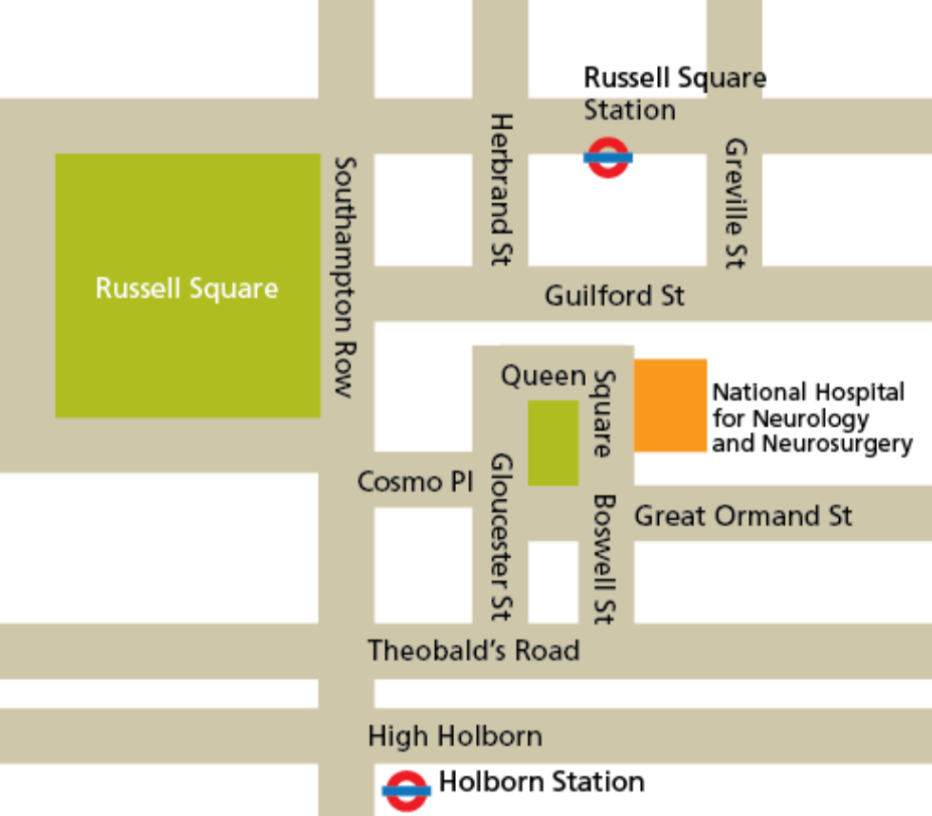
Space for notes and questions

First published: Date last reviewed:
Date next review due:
Leaflet code: [CONTACT THE PATIENT INFORMATION CO-ORDINATOR]
© University College London Hospitals NHS Foundation Trust

